Architecture Document

1. Application Architecture
Selected Architecture: Microservices Architecture
PID-Guard follows a Microservices Architecture to ensure modularity, scalability, and flexibility. Each component of the system operates independently and communicates through APIs.
Why Microservices?
- Easy to scale detection engine independently
- Modular design (semantic + behavioral modules separate)
- Supports future integration with LLM APIs
- Better fault isolation
System Components
1. Frontend Service
- User interface for prompt input
- Displays results (risk score, status)
- Built using React
2. API Gateway / Backend Service
- Handles incoming requests
- Routes data to detection engine
- Built using FastAPI
3. Detection Engine (Core Service)
Contains:
- Intent Drift Module (semantic analysis using embeddings)
- Behavioral Analysis Module (pattern detection)
- Risk Scoring Engine
4. Database Service
- Stores prompts and results
- Used for analytics and improvement
5. Optional ML Model Service
- Hosts embedding models (Sentence-BERT)
- Can be separated for scaling

Architecture Diagram:

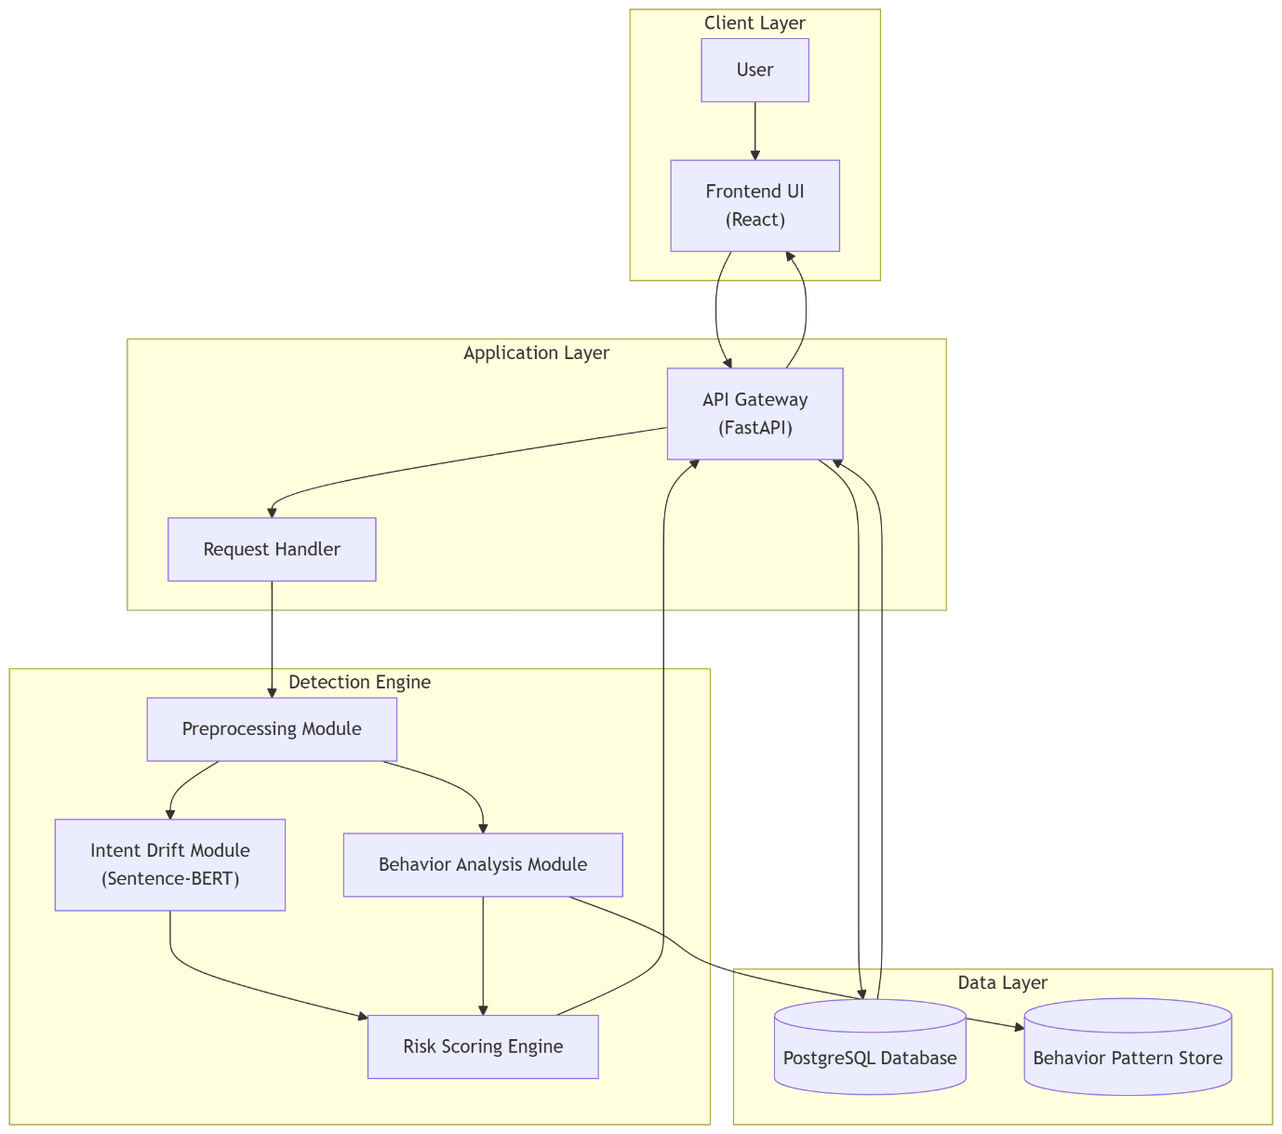
ER Diagram: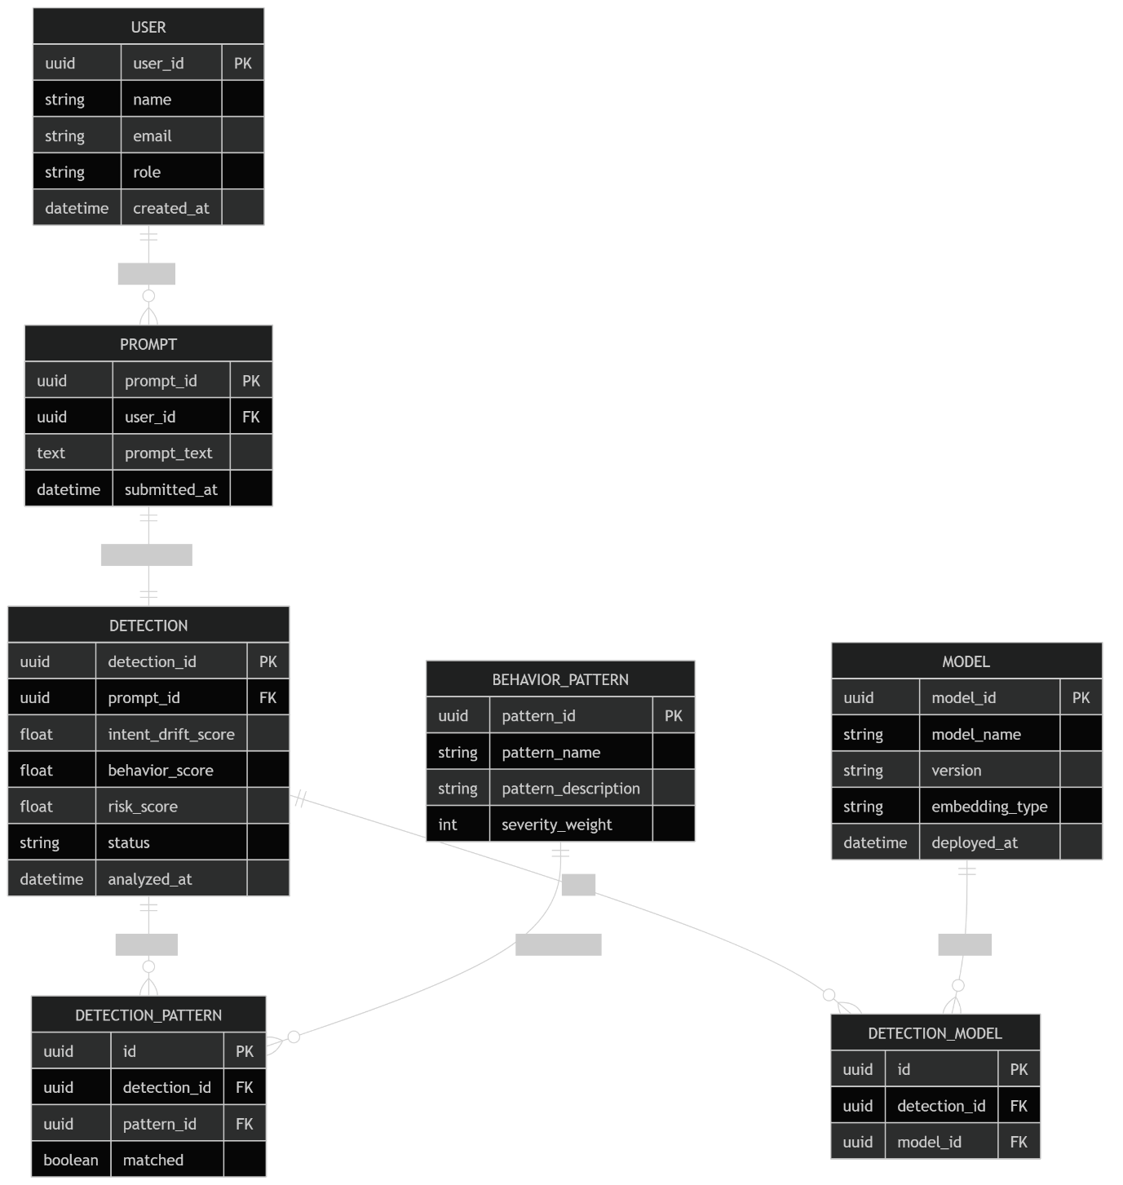

Use Case Diagram:
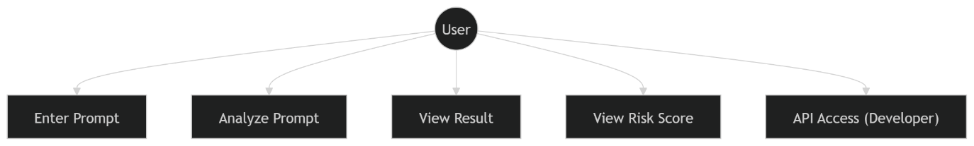

Sequence Diagram:
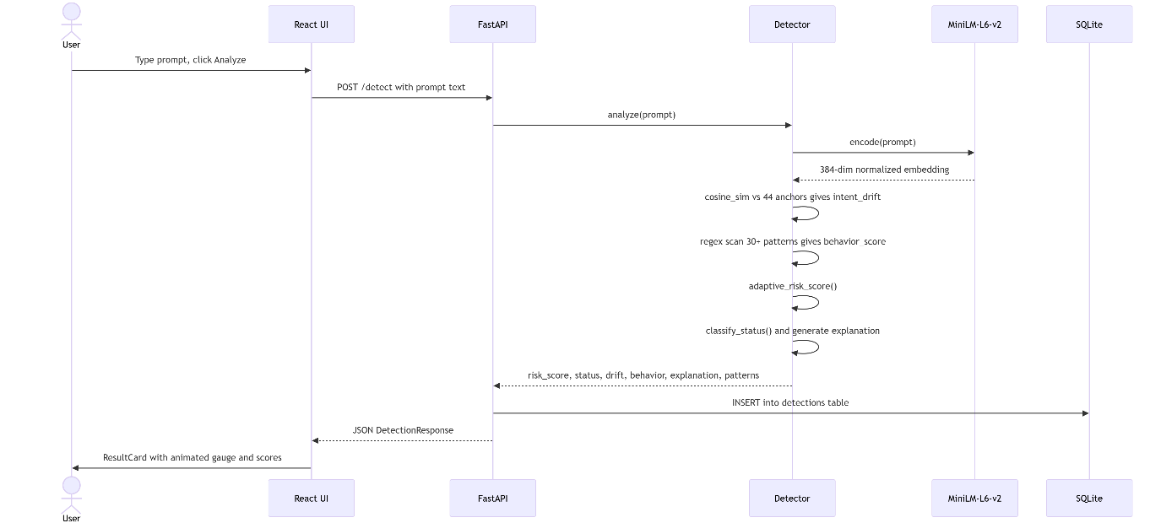

Component Diagram:
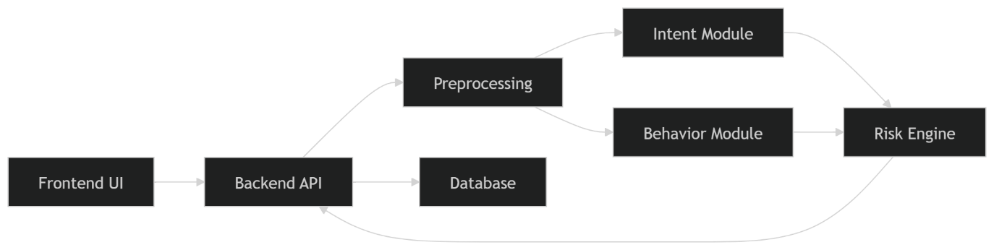

Deployment Diagram: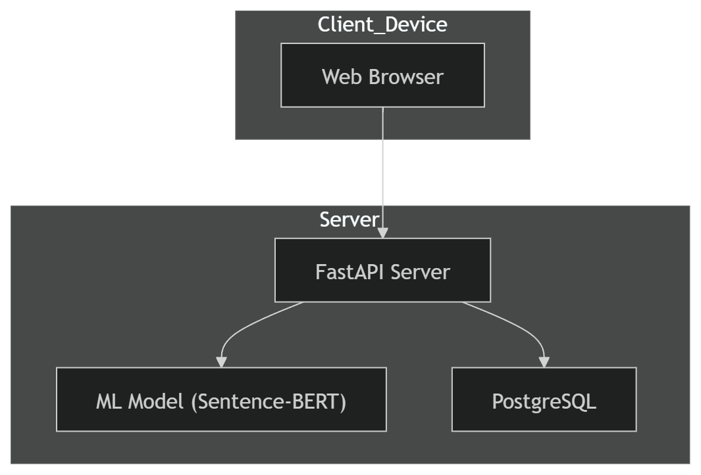
Data Exchange Contract
3.1 Frequency of Data Exchanges
- Real-time (on every prompt submission)
- Each user request triggers detection process
3.2 Data Sets
Input Data:
- User prompt (text)
Intermediate Data:
- Embeddings
- Pattern matches
Output Data:
- Risk score
- Status (Safe / Injection)

3.3 Mode of Exchanges
Mode | Description
API | REST API (FastAPI)
Internal Calls | Function calls between modules
Future | Message queue (Kafka optional)
Example API Request
{
"prompt": "Ignore previous instructions"
}

Example API Response
{
"risk_score": 88,
"status": "Injection Detected"
}

